Welcome. At this stage, you need to complete the test task, and it is not just a test. Your knowledge and research here can help us to build the real model that we will use in production.

You need to create the OCR model prototype for hand-written medical card recognition. You don’t have to write code, you can just write text with your implementation ideas description. Also, please, find some datasets that can be relevant here, it would be very great.

Example of input:

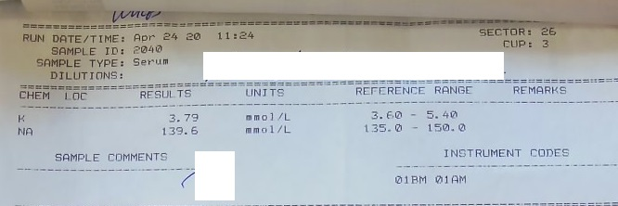

Some useful resources that can be helpful:

1. [OCR models tutorial](https://nanonets.com/blog/attention-ocr-for-text-recogntion/)
2. [Nekrasov medical cards dataset](https://drive.google.com/file/d/1Lgy1mvd3YfxA5I2HSkFVyra4rAggwV6t/)